# Lab: Stacks and Queues

This document defines the exercises for the ["Java Advanced" course @ Software University](https://softuni.bg/modules/59/java-advanced). Please submit your solutions (source code) to all below-described problems in [Judge](https://judge.softuni.org/Contests/1437/Stacks-and-Queues-Lab).

# Working with Stacks

## Browser History

Write a program that takes two types of browser instructions:

* Normal navigation: a URL is set, given by a string;
* The string "**back**" sets the current URL to the last set URL

After each instruction, the program should print the current URL. If the **back** instruction can't be executed, print   
"**no previous URLs**".The input ends with the "**Home**" command, and then you simply have to stop the program.

### Examples

|  |  |
| --- | --- |
| **Input** | **Output** |
| https//softuni.bg/  back  https//softuni.bg/trainings/courses  back  https//softuni.bg/trainings/2056  back  https//softuni.bg/trainings/live  https//softuni.bg/trainings/live/details  Home | https//softuni.bg/  no previous URLs  https//softuni.bg/trainings/courses  https//softuni.bg/  https//softuni.bg/trainings/2056  https//softuni.bg/  https//softuni.bg/trainings/live  https//softuni.bg/trainings/live/details |
| https//google.bg/  https//google.bg/softuni  back  back  https//google.bg/java/advanced  back  https//google.bg/java/oop  Home | https//google.bg/  https//google.bg/softuni  https//google.bg/  no previous URLs  https//google.bg/java/advanced  https//google.bg/  https//google.bg/java/oop |

### Hints

* Use **ArrayDeque<>**.
* Use **String** to keep the current page.
* Use **push()**, when moving to the next page.
* Use **pop()**,when going back.

## Simple Calculator

**Create a simple calculator** that can **evaluate simple expressions** that will not hold any operator different from addition and subtraction. There will not be parentheses or operator precedence.

Solve the problem **using a Stack**.

### Examples

|  |  |
| --- | --- |
| **Input** | **Output** |
| 2 + 5 + 10 - 2 - 1 | 14 |
| 2 - 2 + 5 | 5 |

### Hints

* Use an ArrayDeque**<>.**
* Consider using the **add()** method.
* You can either
  + add the elements and then pop them out
  + or push them and reverse the stack

## Decimal to Binary Converter

Create a simple program that **can convert a decimal number to its binary representation**. Implement an elegant solution **using a Stack**.

**Print the binary representation** back at the terminal.

### Examples

|  |  |
| --- | --- |
| **Input** | **Output** |
| 10 | 1010 |
| 1024 | 10000000000 |

### Hints

* If the given number is 0, just print 0.
* Else, while the number is greater than zero, divide it by 2 and push the reminder into the stack.

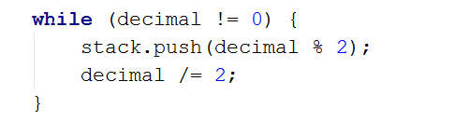

* When you are done dividing, pop all reminders from the stack, which is the binary representation.

1. **Matching Brackets**

We are given an arithmetical expression with brackets. Scan through the string and extract each sub-expression.

Print the result back at the terminal.

**Examples**

|  |  |
| --- | --- |
| **Input** | **Output** |
| 1 + (2 - (2 + 3) * 4 / (3 + 1)) * 5 | (2 + 3)  (3 + 1)  (2 - (2 + 3) * 4 / (3 + 1)) |
| (2 + 3) - (2 + 3) | (2 + 3)  (2 + 3) |

**Hints**

* Use a stack, namely an **ArrayDeque()**.
* Scan through the expression searching for brackets:
  + If you find an opening bracket, push the index into the stack.
  + If you find a closing bracket, pop the topmost element from the stack. This is the index of the opening bracket.
  + Use the current and the popped index to extract the sub-expression.

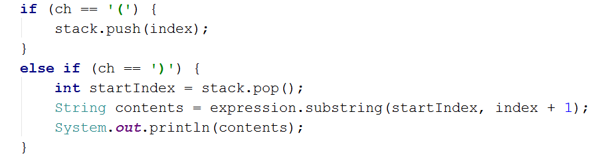

# Working with Queues

1. **Printer Queue**

The printer queue is a simple way to control the order of files sent to a printer device. We know that a single printer can be shared between multiple devices. So to preserve the order of the files sent, we can use a queue.

Write a program which takes filenames until the "**print**"command is received. Then as output, print the filenames in the order of printing. Some of the tasks may be **canceled**. If you receive "**cancel**"you have to remove the first file to be printed. If there is no current file to be printed, print "**Printer is on standby**".

**Examples**

|  |  |
| --- | --- |
| **Input** | **Output** |
| Lab.docx  cancel  cancel  Presentation.pptx  NoteNothing.txt  SomeCode.java  cancel  print | Canceled Lab.docx  Printer is on standby  Canceled Presentation.pptx  NoteNothing.txt  SomeCode.java |
| Presentation.pptx  cancel  Text.txt  cancel  cancel  cancel  print | Canceled Presentation.pptx  Canceled Text.txt  Printer is on standby  Printer is on standby |

### Hints

* Use an **ArrayDeque<>**.
* Use **offer()**, when adding the file.
* Use **pollFirst()**,when printing the file.

## Hot Potato

Hot potato is a game in which **children form a circle and start passing a hot potato**. The counting starts with the first kid. **Every nth toss, the child left with the potato leaves the game**. When a kid leaves the game, it passes the potato forward. This continues repeating **until there is only one kid left**.

Create a program that simulates the game of Hot Potato. **Print every kid that is removed from the circle**. In the end, **print the kid that is left last**.

**Examples**

|  |  |
| --- | --- |
| **Input** | **Output** |
| Sam John Sara  2 | Removed John  Removed Sam  Last is Sara |
| George Peter Sam John Zak  10 | Removed Zak  Removed Peter  Removed Sam  Removed George  Last is John |
| George Peter Misha Sara Kendal  1 | Removed George  Removed Peter  Removed Misha  Removed Sara  Last is Kendal |

1. **Math Potato**

Rework the previous problem by **using a PriorityQueue** so that a **child is removed only on a composite (not prime) cycle** (cycles start from 1).

If a **cycle is prime**, **print the child's name.**

As before, print the name of the child that is left last.

**Examples**

|  |  |
| --- | --- |
| **Input** | **Output** |
| Maria Peter George  2 | Removed George  Prime Maria  Prime Maria  Removed Maria  Last is Peter |
| George Peter Misha Sara Kendal  10 | Removed George  Prime Kendal  Prime Kendal  Removed Kendal  Prime Misha  Removed Misha  Prime Peter  Removed Peter  Last is Sara |

## Browser History Upgrade

Extend "Browser History" with a "**forward**" instruction, which visits URLs that were navigated away from by "**back**".

Each forward instruction visits the next most recent such URL. If normal navigation happens, all potential forward URLs are removed until a new back instruction is given if the forward instruction can't be executed, print   
"**no next URLs**"**.**

### Examples

|  |  |
| --- | --- |
| **Input** | **Output** |
| forward  https//softuni.bg/  https//softuni.bg/trainings/courses  back  forward  https//softuni.bg/trainings/2056  back  forward  forward  https//softuni.bg/trainings/courses  Home | no next URLs  https//softuni.bg/  https//softuni.bg/trainings/courses  https//softuni.bg/  https//softuni.bg/trainings/courses  https//softuni.bg/trainings/2056  https//softuni.bg/trainings/courses  https//softuni.bg/trainings/2056  no next URLs  https//softuni.bg/trainings/courses |
|  |  |
| back  https//google.bg/  https//google.bg/softuni  back  forward  https//google.bg/java/advanced  back  forward  https//google.bg/java/oop  back  https//google.bg/java/oop  Home | no previous URLs  https//google.bg/  https//google.bg/softuni  https//google.bg/  https//google.bg/softuni  https//google.bg/java/advanced  https//google.bg/softuni  https//google.bg/java/advanced  https//google.bg/java/oop  https//google.bg/java/advanced  https//google.bg/java/oop |

### Hints

* Use the solution from Browser History.
* Use **ArrayDequeue<>** as the queue to keep the forward pages.
* Use the **clear()** method to reset the forward pages.
* Use **addFirst()** when adding a page to the forward pages.